

**Calum Murray** server logic, database.

**Euan Morrison** source feed collection.

**Paul Cannings** diary and appointment systems.

**Yolina Kostova** application interface and logic.

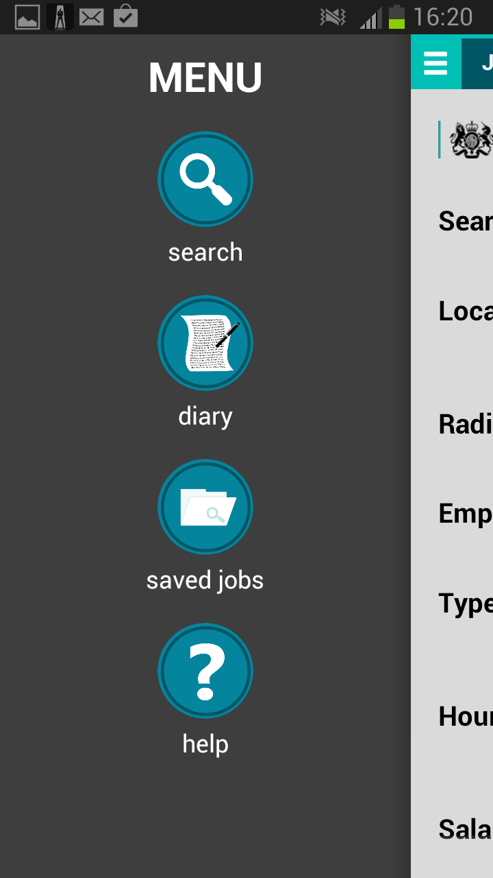 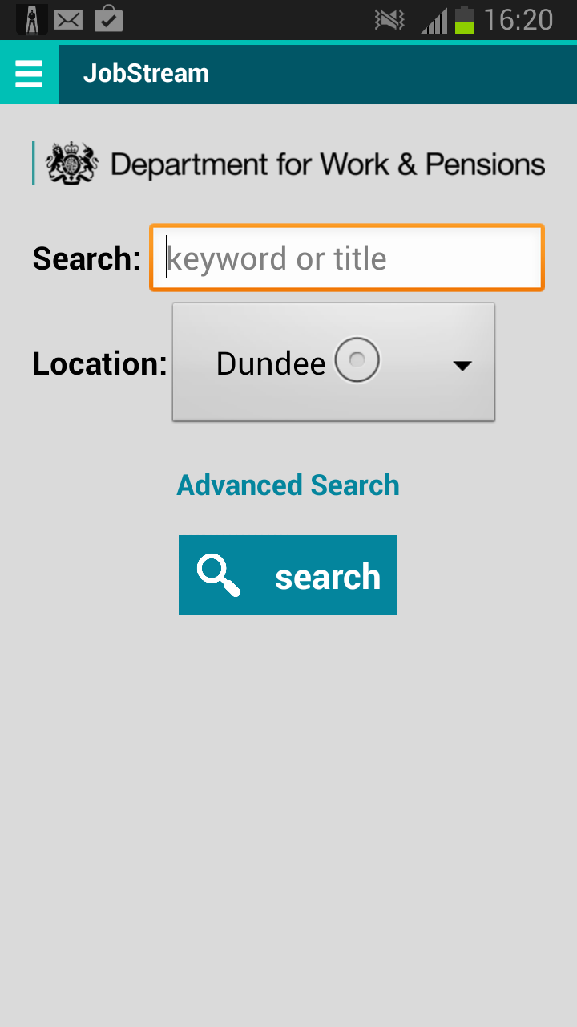 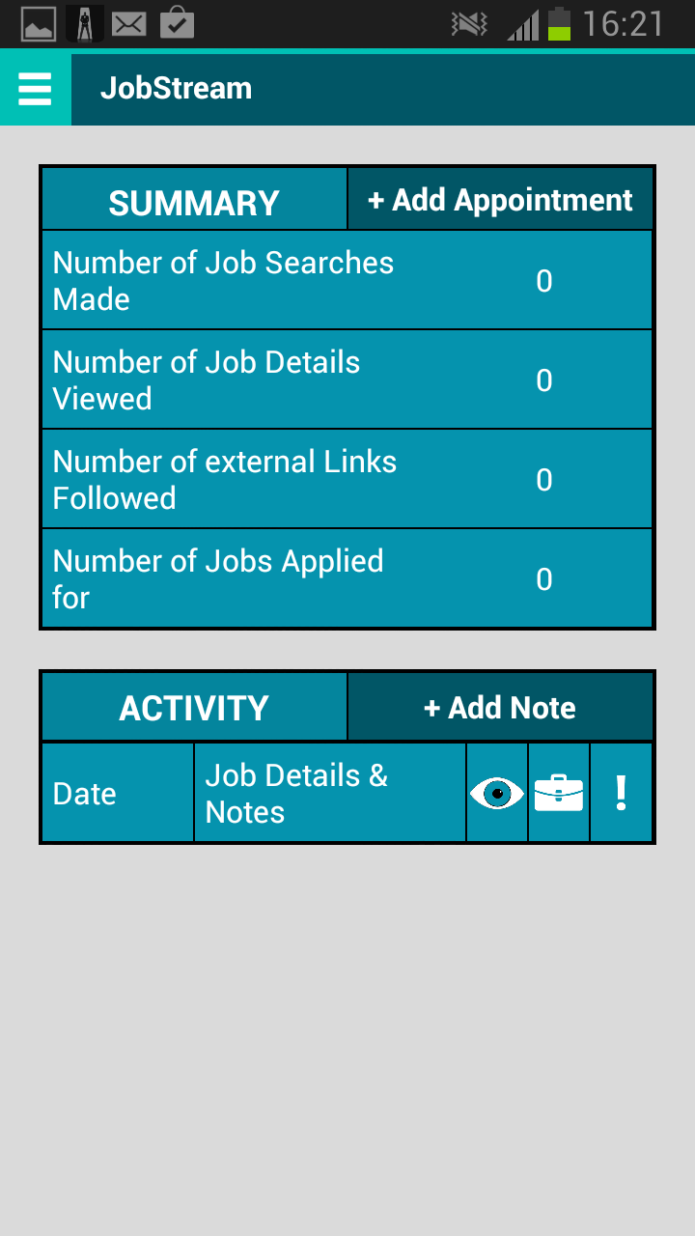 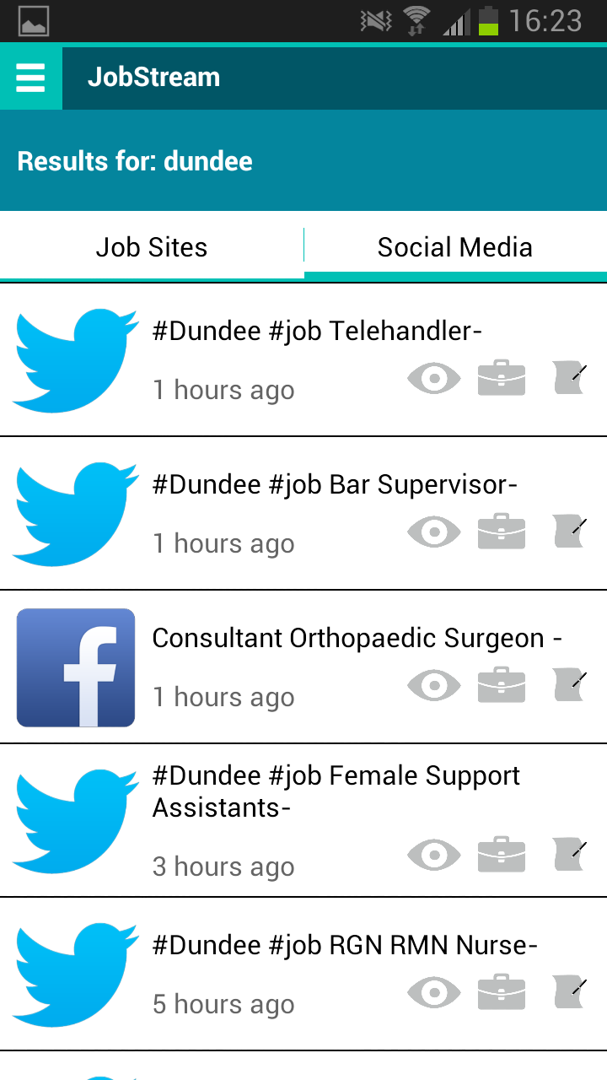

**Problem Statement:**

Dundee Jobcentre Plus, of the Department for Work & Pensions, approached the University of Dundee to produce a cross-platform mobile phone application which will aggregate local job listings from social media sources. This system should find and display job vacancy listings from the various companies who only post jobs on social media sites, rather than traditional job listing sites. Creation and deployment of this app would demonstrate that the DWP are moving forward with emergent technologies.

**Proposed Solution:**

Our proposed solution is a native Android app entitled ***JobStream***, which will facilitate searching for vacancies on traditional websites *and* social media websites, as well as automatically logging users’ job seeking efforts.

The *Search* feature allows finding vacancies using a combination of user-defined *title* and *location* filters. Our sources currently include *Twitter*, *Facebook*, *Indeed*, *Guardian Jobs* and *S1Jobs*, with the results being separated into two different sections: *Job Sites* results and *Social Media* results. These sections can be easily toggled between.

The *Diary* aims to show the user’s activity log in a readable format for their advisor. There is a *Summary* section to offer valuable information immediately available at a glance, followed by a more detailed table of *Activity / History*, modelled after the “*Looking for Work*” sheet currently used by individuals claiming Jobseeker’s Allowance.

**Benefits:**

* Automated collection and aggregation of vacancy search results.
* Ability for users to save individual search results as notable, or to be applied for later.
* Through Jobseeker’s Allowance claimants having activity logged automatically:
  + No longer necessary for claimants to fill in paper-based “Looking for Work” forms.
  + Advisors are presented with a concise activity summary as well as a detailed breakdown.
  + Improves accountability by presenting advisors with unbiased evidence.

**Legal:**

With each job source, different conditions of use are stated in their Terms of Service. In each of the sources we have implemented, a direct method of acquiring results is permitted within a certain request limit or under a particular conditions. Before release and distribution of the app, results provider should be contacted separately to establish a working relationship with them.